Sandip Care Ticket Guidelines (Student)
First, visit https://wecare.sandipfoundation.org Use your credentials to log in and create a new ticket.
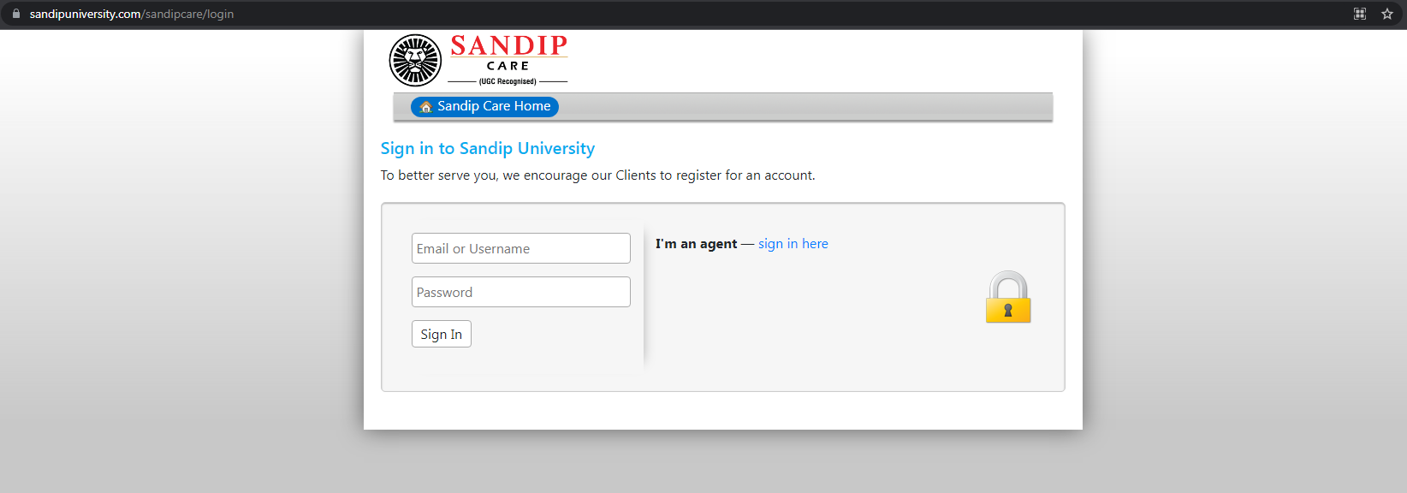

Click on “Create a New Ticket”.
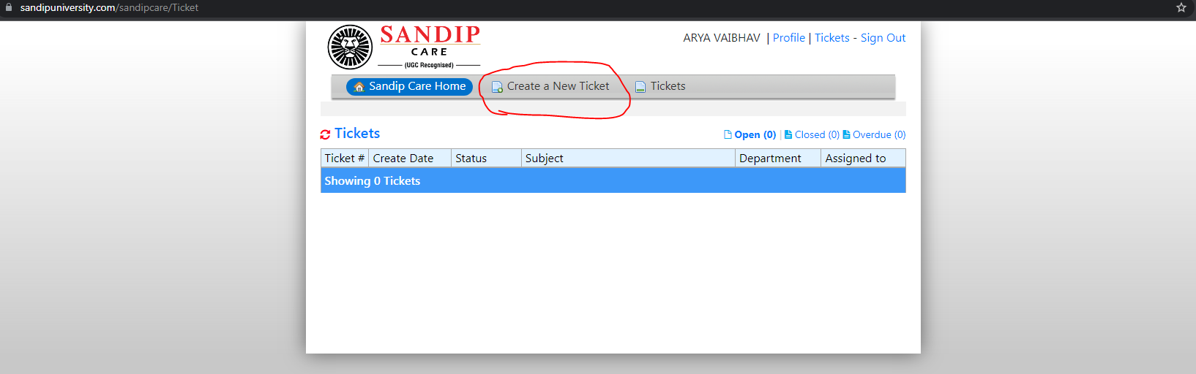

Fill out the form by selecting the relevant department from the “Help Topics” dropdown menu.
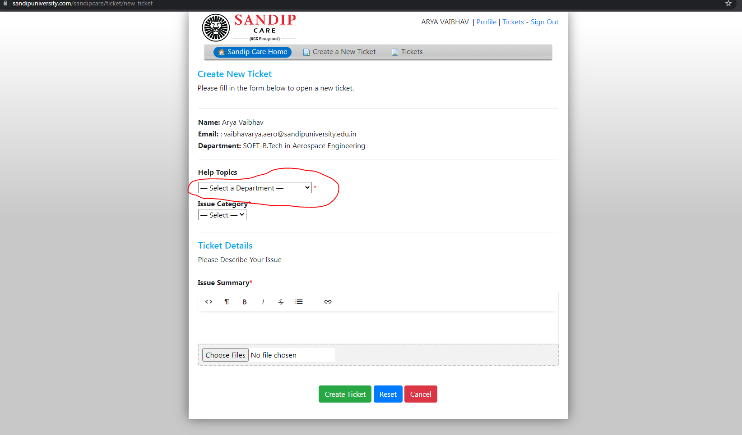

Next, select the issue from the “Issue Category” dropdown menu.
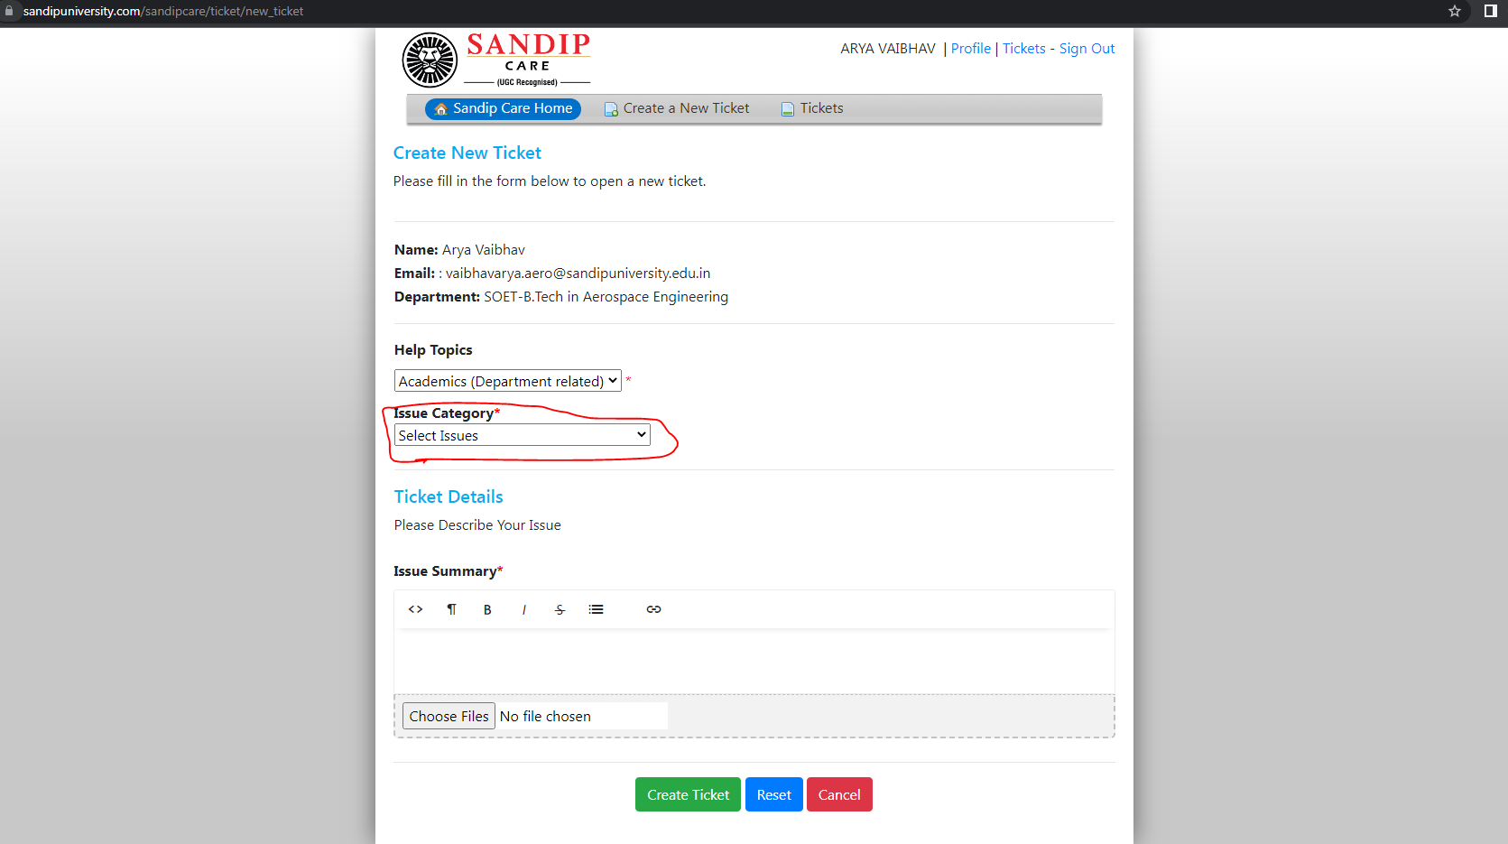

After choosing the issue, briefly explain the issue in the box titled “Issue Summary”.
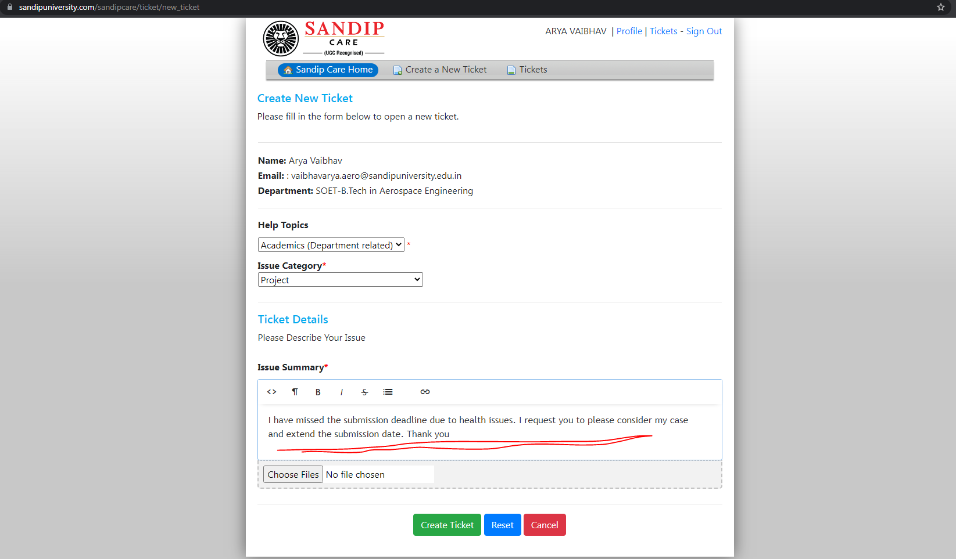

Choose relevant files, if any, and add them to the form.
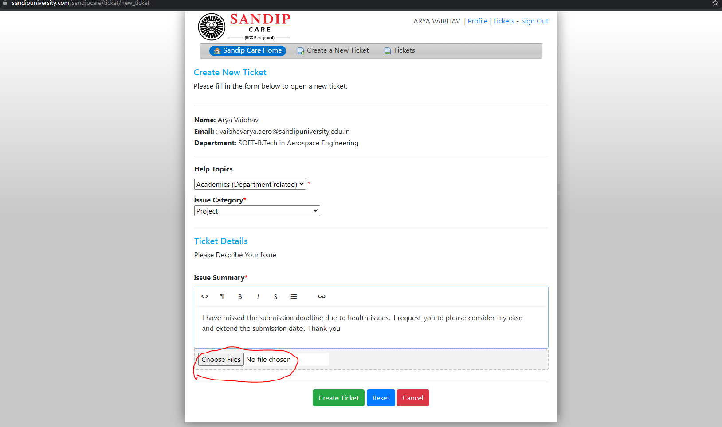

Go through the form. If you are satisfied with the information you have entered, click on “Create Ticket” to submit your form. If you wish to revise the information entered, click on “Reset” and rework your form. If you do not wish to submit a ticket, click on “Cancel”.
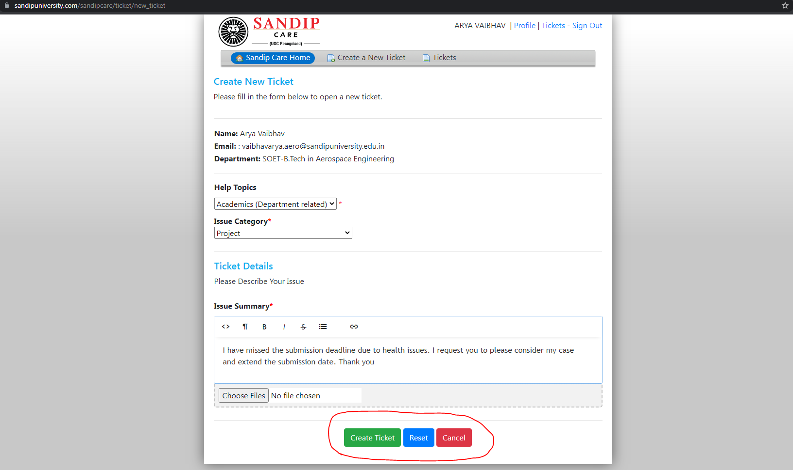

After submitting your ticket, you will be able to view the status of your ticket and the name of the person to whom the ticket has been submitted. The ticket will first be submitted to your tutor. If he/she is unable to resolve the issue, the ticket will be forwarded to your HoD. If the HoD is unable to assist, the ticket will reach your Dean. Finally, the Management will solve the issue if your Dean is unable to do so.
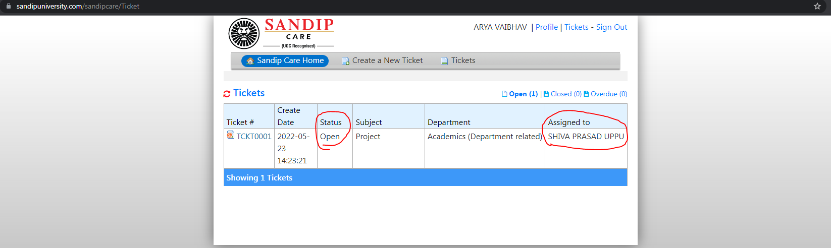

If you wish to view your ticket, click on the “Ticket Number”.
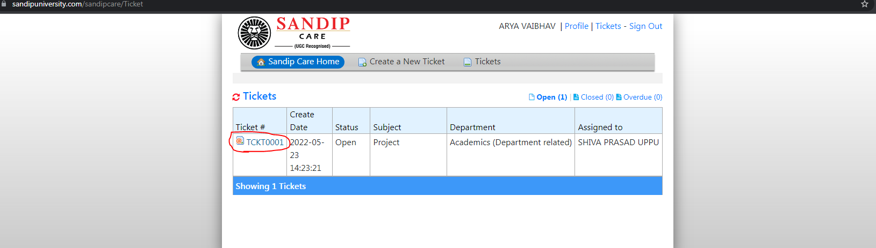

If you wish to add some information that you may have missed out earlier, mention the same in the “Post a Reply” box.
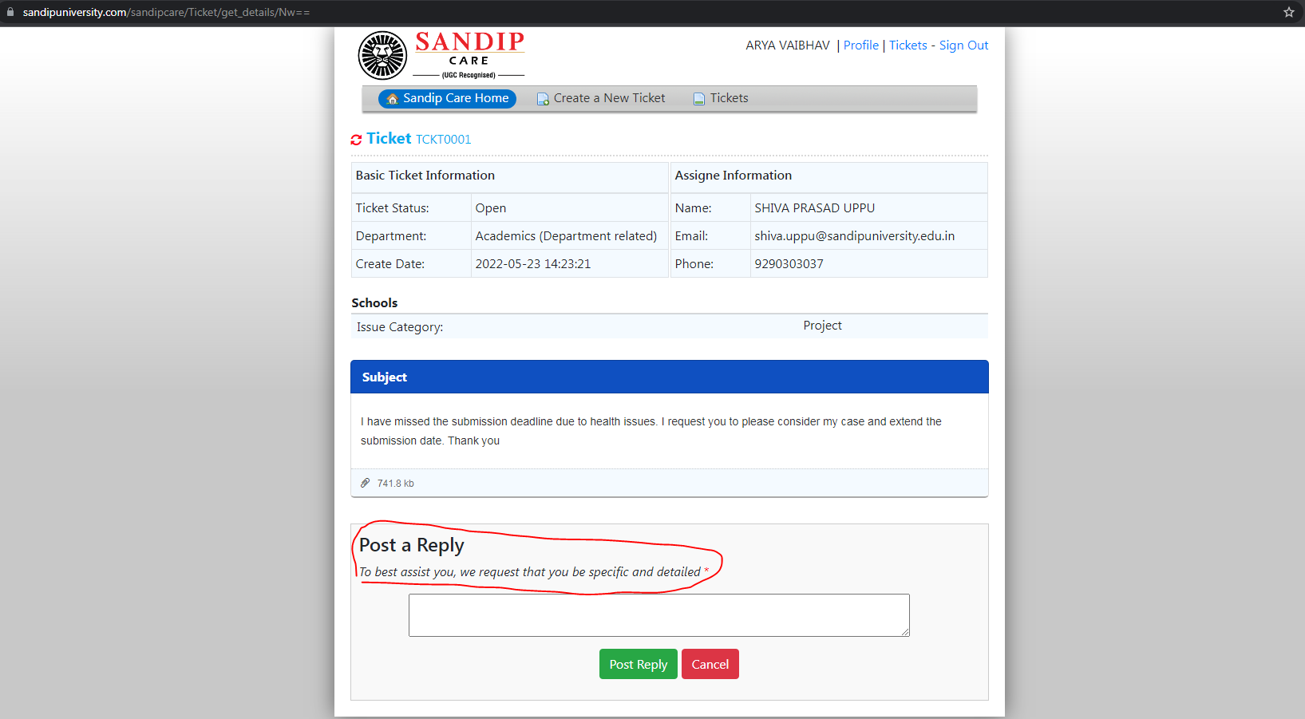

After filling the additional information, click on “Post Reply” to update the ticket. If you do not wish to make any changes, click on “Cancel” to keep the ticket as it is.
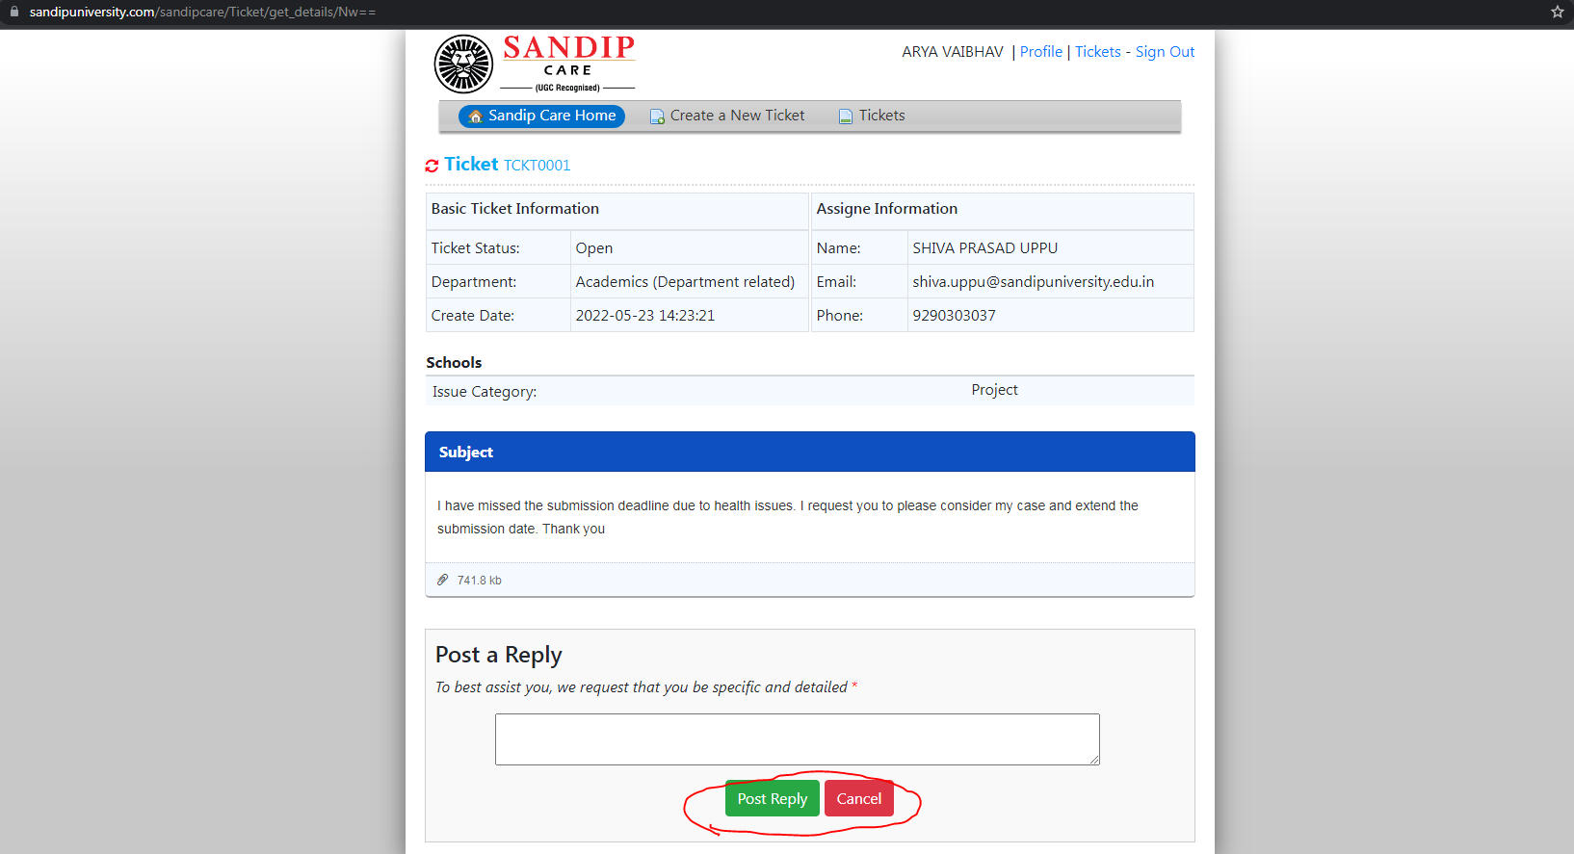

If you are done, click on “Sign Out” to safely log out of the portal.
